

Year 11 ATAR Chemistry 2024

Test 3 – Organic & Intermolecular Forces

Weighting: 3.75%
Time: 55 min

Marks: / 56 %

Name___________________________________

Section One: Multiple-choice (10 Marks)
This section has 10 questions. Circle the most correct answer.
No marks will be given if more than one answer is completed for any question.
Suggested working time: 10 minutes.
_____________________________________________________________________________________

- What is an unsaturated hydrocarbon?

- A hydrocarbon which contains only single carbon – carbon bonds.
- A hydrocarbon which contains at least one double or triple carbon – carbon bond.
- An alkane.
- A hydrocarbon which only contains one carbon atom per molecule.

- The general formula of cycloalkene is

(a) C_{n}H_{2n}
(b) C_{n}H_{2n+2}
(c) C_{n}H_{2n-1}
(d) C_{n}H_{2n-2}

3. Which one of the following shows the structural formula of 4-methyl-2-pentyne?
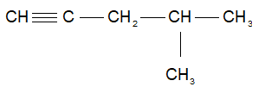
(a)

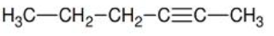
(b)

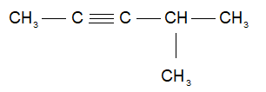
(c)

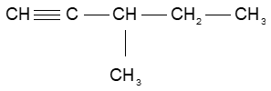
(d)

4. Which of the following is the correct equation for the complete combustion of octane?

  - 2 C₈H₁₈ + 17 O₂ → 16 CO + 18 H₂O
  - C₃H₈ + 5 O₂ → 3 CO₂ + 4 H₂O
  - 2 C₈H₁₈ + 9 O₂ → 16 C + 18 H₂O
  - 2 C₈H₁₈ + 25 O₂ → 16 CO₂ + 18 H₂O

5. When ethene gas is reacted with bromine water, which of the following gives the correct product

or products?

(a) bromoethene and hydrogen bromide
(b) 1,1-dibromoethane
(c) 1,2- dibromoethane
(d) 1,1-dibromoethene

6. Which one of the following molecules is a polar molecule?

  - CO₂
  - O₂
  - NH₃
  - CH₄

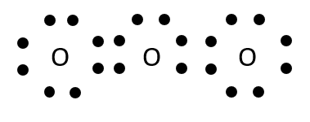
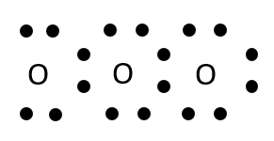
7. Which is the correct electron-dot diagram for ozone (O₃)?
(a) (b)

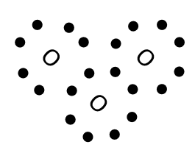
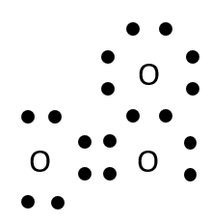
(c) (d)

8. Which of the following properties of water cannot be explained by the formation of hydrogen bonds?

- The relatively low vapour pressure of water.
- The molecular shape of water.
- The relatively high melting point of water.
- The lower density of solid water compared to liquid water.

9. Which of the following lists substances in increasing strength of intermolecular forces?

- H₂ < CH₄ < C₂H₆ < C₂H₅Cl < H₂O
- C₂H₄ < C₂H₅OH < Cl₂ < NH₃ < H₂O
- Cl₂ < NH₃ < C₂H₄ < H₂O < C₂H₅OH
- NH₃ < Cl₂ < C₂H₅OH < C₂H₄ < H₂O

10. Consider the information given in the following table.

 | Toluene | Butane-1,4-diol
Structural diagram
Molar mass, M (g mol⁻¹) | 92.134 | 90.12
Vapour pressure at 50 °C (kPa) | 12.28 | 0.014

Which is the best explanation for the difference in vapour pressure of these two compounds?

- Toluene has a higher molar mass than butane-1,4-diol
- Butane-1,4-diol has fewer carbon atoms in its structure than toluene
- Toluene has stronger dispersion forces than butane-1,4,-diol
- Butane-1,4-diol has stronger intermolecular forces than toluene

End of Section One
Section Two: Short answer (46 Marks)
This section has five (5) questions. Answer all questions. Write your answers in the spaces provided.
Suggested working time: 45 minutes.
_____________________________________________________________________________________

11. Give the correct IUPAC name for the following hydrocarbons: (6 marks)

Structure | Name
 | 3-ethyl- 2-methyl hexane
 | 1,1-dibromo ethene
 | 1-ethyl-3-methyl benzene

12. (a) Consider the two incorrectly named organic substances in the table below. Draw full structural
diagrams, showing all bonds, for the organic substances named, and then give each its correct
IUPAC name. (8 marks)

Incorrect name | Full Structural diagram | IUPAC name
2,3-dichloro-4-hexene | 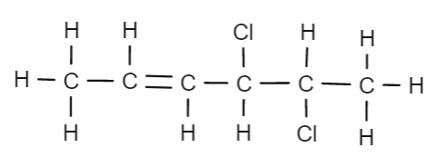 | 4,5-dichloro-2-hexene
1,1-dichloro-2-propyl propene | 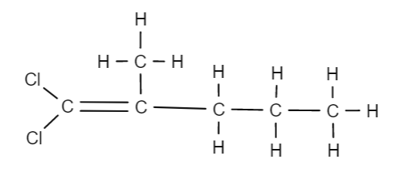 | 1,1-dichloro-2-methyl-1-pentene

(b) The two organic compound in part (a) are isomers. What are isomers? (2 marks)

Isomers are molecules with the same molecular formula (i.e. the same number of
atoms of each element), (1)
but different structural arrangements of the atoms within the molecule. (1)

(c) Draw structural diagrams for two more isomers for the compounds in part (a). (4 marks)

Any two molecules with the molecular formula C₆H₁₀Cl₂

Examples include:
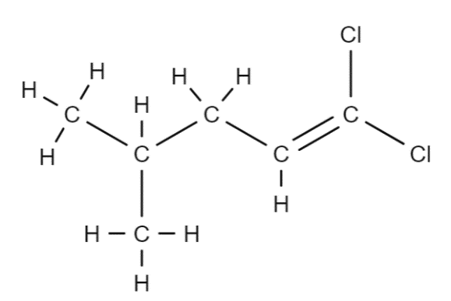
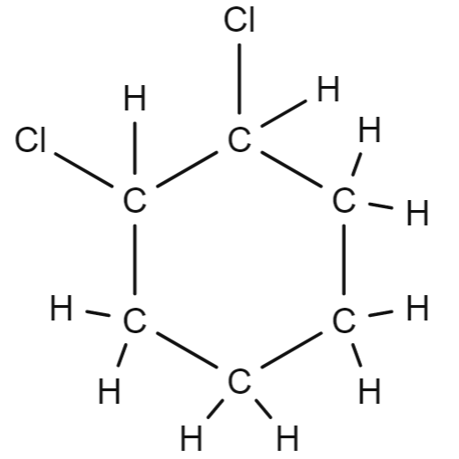
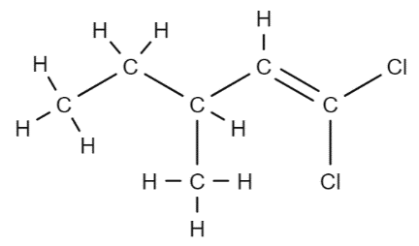
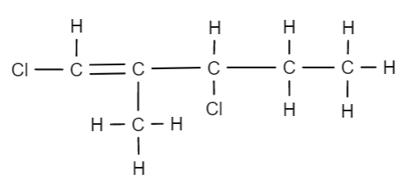

13. Complete the following equations by adding the missing reactants or products. In each case, draw a structural diagram of the molecules. (5 marks)
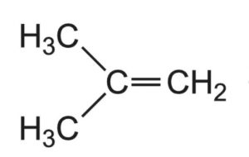
(a)
Diagram:
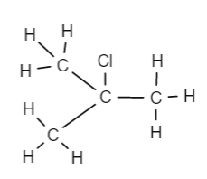

(1 mark)
+ HCl (g)

Diagram:

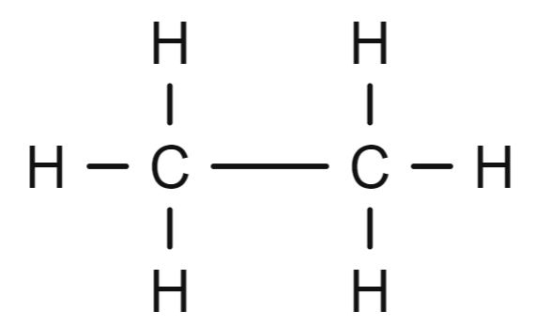

(1 mark)

Name:
+ Cl₂ (aq) CH₃CH₂Cl +
Diagram:

H - Cl

(1 mark)
(b)

Diagram: Any molecule with the molecular formula C₆H₁₂
1 mark if molecular formula only

(2 marks)
(c)

+ 9 O₂ (g) 6 CO₂ (g) + 6 H₂O

14. For each species listed in the table below, Lewis structure, representing all valence shell electron pairs either as : or as –, state or draw the shape of the molecule and state the polarity of the molecule. (9 marks)
(for example, water |  | or |  | or |  | )
Species | Lewis Structure  (Showing all valence shell electrons) | Shape  (Sketch or name) | Polarity of molecule  (Polar or non-polar)
Sulfur monoxide  SO | 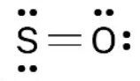 | linear | polar
Sulfur Dichloride  SCl₂ | 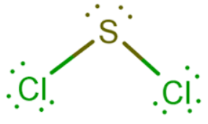 | V shaped (bent) | polar
Sulfur trioxide  SO₃ | 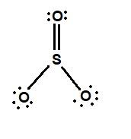 | Trigonal planar | Non- polar

15. (a) Identify the predominant force of attraction between molecules of the following solids.
(4 marks)

Solid | The predominant force
CO₂ | Dispersion
NH₃ | Hydrogen bonding
CH₂O | Dipole-dipole
O₂ | Dispersion

(b) For each of the following pairs of molecules

- Circle the one that you would expect to have the highest boiling point, and
- Give a brief explanation for your choice.

(i) Hydrogen chloride OR Hydrogen bromide (4 marks)

Both are polar molecules with dipole-dipole forces between molecules (1)
However, hydrogen bromide has more electrons (1) so therefore it has stronger
dispersion forces than hydrogen chloride and therefore will require more heat energy to disrupt. (1)

(ii) carbon dioxide OR sulfur dioxide (4 marks)

Sulfur dioxide is polar and has dipole-dipole forces between molecules (1)
whereas carbon dioxide is non-polar and only has dispersion forces between
molecules (1)
Dipole-dipole forces are much stronger than dispersion forces and therefore will
require more heat energy to disrupt. (1)

End of Test

